**PROJECT REPORT**

**(Submitted for the Degree of B.Com. Honours in Accounting & Finance Under the University of Calcutta)**

**Title of the project**

**“MICRO-FINANCE INSTITUTION IN INDIA”**

**Submitted by**

**Name of the candidate: Prerna Pandey**

**Registration No.: 011-1211-0634-21**

**C.U Roll No.: 211011-11-0117**

**College ID: 20210513**

**Name of the college: ACHARYA JAGADISH**

**CHANDRA BOSE COLLEGE**

**Supervised by**

**Name of the Supervisor: PROF.** **PRITHA ADHIKARI**

**Name of the College:** **ACHARYA JAGADISH**

**CHANDRA BOSE COLLEGE**

**Month & Year of Submission**

**MAY 2024**

**ACKNOWLEDGEMENT**

It is a matter of immense pleasure to present this project on “**Micro-Finance Institutions in India**”.

I take this opportunity to thank our respected **Principal** **Mr. Dr. Purna Chandra Maity**

for giving me an opportunity to work on this field.

I am grateful to our respected **HOD** Dr **Supratim Dey** Without whom this project would not have been successful.

I am very thankful to my **Supervisor Pritha Adhikari for** her fullsupport in completing this project work.

Finally, I am grateful to acknowledge my family and friends and all the teachers who filled the questionnaire providing me full support and coordination without which this project would not be possible.

**Supervisor’s Certificate**

This is to certify that Ms. **Prerna Pandey** a student of B.com honours in Accounting & Finance of **ACHARYA JAGADISH CHANDRA BOSE COLLEGE** under the University of Calcutta has worked under my supervision and guidance for his Project Work and prepared a Project Report with the title **Micro-Finance Institutions in India**.

The Project report, which she is submitting is her genuine and original work to the best of my knowledge.

Signature:

Name:

Designation:

Name of the college:

Place:

Date

**Student’s Declaration**

I hereby declare that the Project Work with the title **“MICRO-FINANCE INSTITUTIONS IN INDIA”** submitted by me for the partial fulfilment of the degree of B.Com. Honours in Accounting & Finance under the University of Calcutta is my original work and has not been submitted earlier to any other University / Institution for the fulfilment of the requirement for any course of study.

I also declare that no chapter of this manuscript in whole or in part has been incorporated in this report from any earlier work done by others or by me. However, extracts of any literature which has been used for this report has been duly acknowledged providing details of such literature in the references.

Signature:

Name: Prerna Pandey

C.U Registration No. 011-1211-0634-21

C.U Roll No. 211011-11-0117

Place:

Date

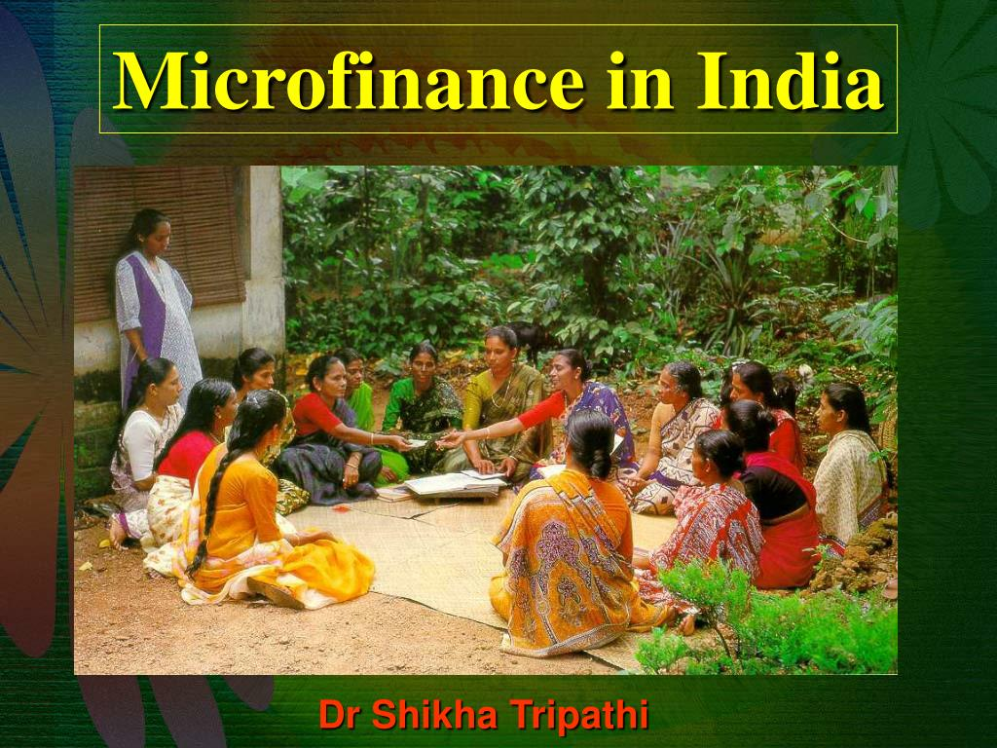

**INDEX**

|  |  |  |
| --- | --- | --- |
| **Chapter** | **Topics** | **Page No.** |
|  | **Acknowledgement** | 2 |
|  | **Supervisor’s Certificate** | 3 |
|  | **Student’s Declaration** | 4 |
| **Chapter 1: Introduction** | 1.1 Background | 8 |
| 1.2 Need of the Study | 9 |
| 1.3 Literature Review | 10 |
| 1.4 Case Study | 11 |
| 1.5 Objective of the Study | 14 |
| 1.6 Research Methodology | 15 |
| 1.7 Limitations | 16 |
| **Chapter 2:**  **Conceptual Framework** | 2.1 Terminologies | 17 |
| 2.2 National Scenario   * NABARD | 18 |
| 2.3 International Scenario | 20 |
| **Chapter 3** | **Presentation of Data Analysis and Findings** | 21 |
| **Chapter 4** | 4.1 Conclusion and Recommendations | 25 |
| 4.2 Bibliography | 28 |

**Chapter 1: Introduction**

*"Micro Finance recognizes that poor people are remarkable reservoirs of energy and knowledge. And while the lack of financial services is not just a sign of poverty, today it is looked like an untapped opportunity to create markets, bring people in from the margins and give them tools to help themselves."*

**- Kofi Annan Former Secretary General, UN**

Micro Finance, in general, refers to the provision of financial services including small value loans to households, small businesses and entrepreneurs who lack access to formal banking services. It is an effective tool for financial inclusion which involves providing micro finance and related services in a sustainable manner to enable the poor and the marginalized to achieve social equity and empowerment. Women constitute a vast majority of users of micro finance facilities. The Indian Micro Finance sector has witnessed a phenomenal growth over the years. The number of institutions providing micro finance services has gone up from a few to several hundred. Micro Finance Institutions (MFIs) currently operate in 29 States, 4 Union Territories and 563 districts in India. The reported 168 MFIs with a branch network of 10,233 and 89,785 employees have reached out to more than 3 crore clients with an outstanding loan portfolio of Rs. 46,842 crores. The average loan outstanding per borrower stood at Rs. 12,751 and 85% of loans were used for income generation purposes. The SHG bank linkage program has grown equally to touch the lives of people through SHGs with an outstanding loan portfolio of Rs. 61,581 crores.

1. **1 Background**

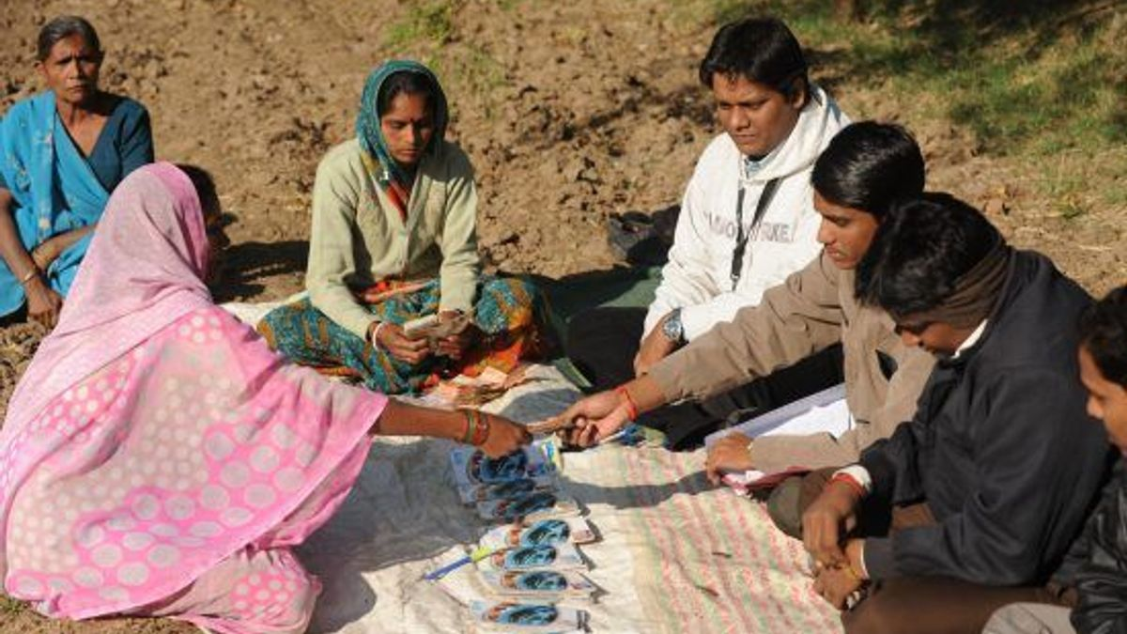Microfinance is not a new concept. Small operations of this type have existed since the 18th century. The first occurrence of microlending is attributed to the Irish Loan Fund system, introduced by Jonathan Swift, which sought to improve conditions for impoverished Irish citizens. In its modern form, microfinancing became popular on a large scale in the 1970s. The first organization to receive attention was the Grameen Bank, started in 1983 by Muhammad Yunus in Bangladesh.10 In addition to providing loans to its clients, the Grameen Bank also suggests that its customers subscribe to its "16 Decisions," a basic list of ways that the poor can improve their lives.11 The 16 Decisions touch upon a wide variety of subjects, ranging from a request to stop the practice of issuing dowries upon a couple's marriage, to keeping drinking water sanitary. In 2006, the Nobel Peace Prize was awarded to both Yunus and the Grameen Bank for their efforts in developing the microfinance system.5 The Nobel Prize. "Grameen Bank - Facts." There are other microfinance operations around the world. Some larger organizations work closely with the World Bank, while other smaller groups operate in different nations. Some organizations enable lenders to choose exactly who they want to support, categorizing borrowers with criteria such as level of poverty, geographic region, and type of small business.

**1.2 Need of the Study**

In India, a vast population remains excluded from the formal financial system. Microfinance institutions (MFIs) step in, offering a lifeline to these millions. But are they truly the key to financial inclusion and poverty alleviation? Studying MFIs is crucial to unlocking this answer.

Here are 6 reasons why studying microfinance institutions in India is important:

1. **Financial Inclusion:** Microfinance plays a vital role in including a large unbanked population in India's formal financial system. Studying MFIs helps understand how they address this challenge and promote financial empowerment.
2. **Poverty Alleviation:** Microloans can be a powerful tool for poverty reduction. By studying MFIs, you can analyze their effectiveness in supporting income generation and uplifting disadvantaged communities.
3. **Economic Development:** A thriving microfinance sector can contribute significantly to India's economic growth. Studying MFIs helps assess their impact on small businesses, entrepreneurship, and overall economic activity.
4. **Policy and Regulation:** The regulatory framework surrounding MFIs is crucial for their sustainable growth. Studying MFIs helps evaluate the effectiveness of existing policies and identify areas for improvement.
5. **Financial Innovation:** The microfinance sector is constantly evolving with new models and technologies. Studying MFIs helps understand these innovations and their potential to improve financial inclusion for all.
6. **Social Impact:** Beyond financial benefits, microfinance can contribute to broader social development. Studying MFIs helps assess their impact on areas like education, healthcare, and social mobility within communities.
7. **Sustainability:** The long-term viability of MFIs is crucial for their continued support to low-income populations. Studying MFIs helps assess their financial sustainability and ability to deliver services without falling into debt traps.
8. **Technological Disruption:** The rise of fintech and mobile banking is transforming the microfinance landscape. Studying MFIs helps analyze how they are adapting to these technological advancements and how it affects their reach and effectiveness.

**1.3 Literature Review**

Microfinance institutions (MFIs) play a critical role in India's financial landscape, aiming to empower low-income populations and drive economic development. This literature review explores various aspects of MFIs in India, drawing on eight key research papers:

**Financial Inclusion and Poverty Alleviation:**

1. **Authors:** *Robinson, M. (2001).*

**Title**: *The Microfinance Revolution: Sustainable Finance for the Poor*

This seminal work explores the potential of microfinance in poverty reduction and financial inclusion. Robinson argues that MFIs, by providing access to credit and financial services, can empower individuals and families to break the poverty cycle.

1. **Authors:** *Morduch, J. (2000).*

**Title**: *The Microfinance Promise: Evidence from Bangladesh*

Morduch's research examines the effectiveness of microfinance programs in Bangladesh, a pioneer in the field. He analyzes the impact on income generation, household welfare, and borrower empowerment.

**Economic Development and Policy:**

1. **Authors:** *Rhyne, E., & Holt, S. (1994).*

**Title**: *Women in Finance and Enterprise Development*

This paper highlights the importance of MFIs in fostering women's entrepreneurship and economic development. Rhyne and Holt explore how financial access empowers women to start and grow businesses, contributing to the overall economy.

1. **Authors:** *Puttaswamy, G. (2009).*

**Title:** *Microfinance in India: A Review of the Policy Framework*

Puttaswamy's work delves into the policy framework governing MFIs in India. This paper analyzes how regulations impact MFI operations, sustainability, and client protection.

**Client Protection and Social Impact:**

1. **Authors:** *Armendariz, B., & Morduch, J. (2005).*

**Title:** *The Microfinance Revolution: Myth versus Reality*

Armendariz and Morduch offer a critical perspective on microfinance, examining potential risks such as over-indebtedness and exploitative lending practices. They emphasize the importance of client protection mechanisms and responsible lending practices.

1. **Authors:** *Sharma, M. (2012).*

**Title:** *Microfinance and Women Empowerment in India*

Sharma's research investigates the social impact of microfinance, particularly on women's empowerment. This paper analyzes how access to financial resources can enhance women's decision-making power and social mobility.

**Innovation and Sustainability:**

1. **Authors:** *Ahlin, D., & Molin, A. (2014).*

**Title:** *Financial Inclusion and Fintech: A Review of the Literature*

This paper explores the role of financial technology (fintech) in revolutionizing microfinance delivery. Ahlin and Molin analyze how mobile banking and other fintech solutions can improve MFI reach, efficiency, and accessibility for low-income populations.

1. **Authors:** *Rhyne, A. (2006).*

**Title:** *The Long View of Microfinance*

Rhyne's work examines the long-term sustainability of MFIs. This paper analyzes factors impacting financial viability, resource mobilization, and the need for innovative approaches to ensure the continued success of microfinance institutions.

This selection of research papers provides a starting point for understanding the multifaceted role of MFIs in India. It highlights the potential for financial inclusion, poverty alleviation, and economic development, while also acknowledging potential challenges and the need for responsible practices and regulatory frameworks.

* 1. **Case Study**

1. **Impact of Microfinance on Rural Women in Andhra Pradesh, India:**

This case study examines the experiences of rural women in Andhra Pradesh who have accessed microfinance services. Through interviews and surveys, it explores how microfinance has empowered women by providing them with access to credit for income-generating activities such as small-scale agriculture and entrepreneurship.

1. **Financial Inclusion Through Self-Help Groups (SHGs) in Southern India:**

This case study investigates the role of SHGs in promoting financial inclusion in rural communities in southern India. It highlights how SHGs, facilitated by microfinance institutions, have enabled marginalized populations, particularly women, to access financial services, manage savings, and invest in livelihood opportunities.

1. **Socio-Economic Impact of Microfinance in Rural Villages of Bangladesh and India:**

Drawing on comparative data from rural villages in Bangladesh and India, this case study assesses the socio-economic impact of microfinance interventions. It examines how microfinance has contributed to poverty reduction, improved livelihoods, and empowered communities in both countries, highlighting contextual differences and best practices.

1. **Empowerment of Tribal Communities Through Microfinance in Eastern India:**

This case study focuses on the impact of microfinance on tribal communities in eastern India. It explores how microfinance institutions have tailored their services to meet the unique needs and cultural contexts of tribal populations, leading to increased financial inclusion, socio-economic development, and empowerment.

1. **Entrepreneurial Success Stories: Microfinance Beneficiaries in Urban Slums of Mumbai, India:**

This case study profiles successful entrepreneurs who have accessed microfinance services in urban slums of Mumbai. Through in-depth interviews and case analyses, it highlights how microfinance has enabled individuals from marginalized communities to start and grow their businesses, lifting them out of poverty and fostering economic independence.

1. **Expansion Strategies of Microfinance Institutions in Rural India: A Case Study Approach:**

This case study examines the expansion strategies adopted by microfinance institutions to reach rural populations in India. It analyzes the approaches, challenges, and outcomes of MFI initiatives aimed at scaling up operations and extending financial services to underserved regions, providing insights for future expansion efforts.

1. **Innovative Microfinance Models: Case Studies from Various States in India:**

This case study explores innovative microfinance models implemented by MFIs across different states in India. It showcases diverse approaches, such as group lending, digital finance solutions, and value chain financing, and assesses their effectiveness in addressing the financial needs of diverse client segments and promoting sustainable development.

1. **Microfinance and Agriculture: Case Studies of Farmer Cooperatives in Rural India:**

This case study examines the role of microfinance in supporting agricultural development through farmer cooperatives in rural India. It showcases successful examples of cooperatives leveraging microfinance to access inputs, technology, and markets, thereby enhancing farm productivity, income levels, and food security.

1. **Youth Entrepreneurship and Microfinance: Case Studies of Youth-Led Businesses in India:**

This case study highlights the role of microfinance in fostering youth entrepreneurship in India. It profiles young entrepreneurs who have received microfinance support to launch and grow their businesses, demonstrating how access to credit and business development services can empower the next generation of Indian entrepreneurs.

1. **Microfinance and Livelihood Diversification: Case Studies from Coastal Communities in India:**

This case study explores the impact of microfinance on livelihood diversification among coastal communities in India. It examines how microfinance interventions have enabled fishing communities to diversify their income sources, reduce vulnerability to environmental risks, and improve overall resilience.

1. **Women's Empowerment Through Microfinance: Case Studies from SHGs in Rajasthan, India:**

This case study investigates the empowerment outcomes of women participating in Self-Help Groups (SHGs) supported by microfinance in Rajasthan. It documents stories of women who have overcome socio-economic barriers, gained decision-making power, and achieve financial independence through their involvement in SHGs.

1. **Microfinance and Social Impact: Case Studies of Health and Education Initiatives in Rural India:**

This case study explores the social impact of microfinance beyond economic empowerment, focusing on initiatives in health and education in rural India. It showcases how MFIs have partnered with local organizations to provide access to healthcare services, support education initiatives, and improve overall quality of life for marginalized communities.

**1.5 Objective of the Study**

Objective reasons to study microfinance institutions (MFIs) in India:

1. **Assess the Impact on Financial Inclusion:** Analyze how effectively MFIs in India are bringing previously unbanked populations into the formal financial system. This includes examining their reach, targeting strategies, and the types of financial services offered.
2. **Evaluate the Contribution to Poverty Alleviation:** Investigate the role of MFIs in empowering low-income individuals and families to lift themselves out of poverty. This involves analyzing how microloans contribute to income generation, asset building, and improved livelihoods.
3. **Measure the Effect on Economic Development:** Assess the broader impact of MFIs on India's economic growth. This includes studying how microfinance fosters small business creation, entrepreneurship, and overall economic activity at the local and national levels.
4. **Analyze the Regulatory Framework:** Examine the existing regulatory policies and frameworks governing MFIs in India. This involves evaluating their effectiveness in promoting responsible lending practices, client protection, and the long-term sustainability of the microfinance sector.
5. **Identify Potential Risks and Challenges:** Identify and analyze the potential risks associated with microfinance in India. This includes examining issues like over-indebtedness, client exploitation, and the possibility of financial instability within the MFI sector itself.
6. **Explore the Role of Technology:** Investigate how technological advancements, such as mobile banking and financial technology (fintech), are transforming the microfinance landscape in India. Analyze how these innovations are impacting MFI operations, outreach, and efficiency.
7. **Evaluate the Contribution to Social Development:** Go beyond financial outcomes and assess the broader social impact of MFIs in India. This includes examining how microfinance empowers women, promotes social mobility, and contributes to improved health and education outcomes within communities.
   1. **Research Methodology**

**1. Choosing My Approach:**

There are two main ways to approach research: quantitative. For this topic, I decided to use a quantitative approach.

**2. Finding My Information:**

* **Surveys:** I created a survey with questions related to topic. I then distributed it to professionals) through online platforms.
* **Data Collection:** I collected the completed surveys and entered the data into a spreadsheet program for analysis.

**3. Making Sense of it All: Data Analysis:** Once I had all my information (surveys, interview recordings, documents), I analyzed it to find patterns and themes.

**4. Ethical Considerations:**

* Throughout this process, I made sure to follow ethical research practices. This means I obtained informed consent from participants before collecting any data, and I kept all their information confidential.

By following these steps, I was able to gather valuable information to answer my research questions. In the next chapter, I'll share the findings from my research.

* 1. **Limitations**

1. **Data Availability and Reliability:** Data on the impact of MFIs, particularly at the individual borrower level, can be difficult to obtain and may not be entirely reliable. MFIs may not have robust data collection systems, and borrowers may be hesitant to share sensitive financial information.
2. **Selection Bias and Attributing Causality:** Studies analyzing MFI impact often struggle with selection bias. Borrowers who choose to participate in microfinance programs might be inherently more entrepreneurial or financially responsible, making it difficult to isolate the true impact of the loan itself. Attributing observed changes solely to microfinance can be challenging.
3. **Sustainability Concerns:** While initial studies often focus on the positive impact of MFIs, questions remain about their long-term sustainability. High-interest rates, aggressive collection practices, and over-indebtedness can pose risks to both borrowers and the overall microfinance ecosystem.
4. **Focus on Financial Outcomes:** Research often prioritizes financial outcomes like income generation or loan repayment rates. The broader social impact of MFIs on areas like health, education, or gender empowerment might be less well-studied, requiring additional research efforts.
5. **Evolving Landscape and Technological Advancements:** The microfinance landscape in India is constantly evolving with the rise of fintech and mobile banking. Research may not capture the latest trends and adaptations of MFIs, and new models might require fresh research approaches.

**Chapter 2: Conceptual Framework**

This framework explores the role of microfinance institutions (MFIs) in India, analyzing their impact on financial inclusion, poverty alleviation, and overall development. It considers both the national scenario and the international context of microfinance.

**2.1 Terminologies**

* **Microfinance:** Providing financial services (loans, savings, insurance) to low-income individuals and micro-entrepreneurs.
* **Microfinance Institutions (MFIs):** Organizations offering microfinance services. (Types: MFIs, NGOs, cooperatives)
* **Financial Inclusion:** Ensuring access to affordable financial products and services for all.
* **Poverty Alleviation:** Lifting individuals and families out of poverty by increasing income and improving livelihoods.
* **Microcredit:** The provision of small loans to low-income borrowers.
* **Self Help Groups (SHGs):** Informal groups of individuals who come together for savings and microcredit.

**2.2 National Scenario**

* **Significance of MFIs in India:**
  + Addressing financial exclusion in a vast unbanked population.
  + Empowering low-income individuals, particularly women, through microloans.
  + Contributing to poverty reduction and economic development.
* **Challenges:**
  + Over-indebtedness and potential for exploitation.
  + Regulatory framework balancing growth and client protection.
  + Ensuring outreach to underserved populations in rural and remote areas.
* **Government Initiatives:**
  + Promoting SHG-bank linkage programs for financial inclusion.
  + Regulatory frameworks like Microfinance Institutions (Development and Regulation) Act 2011.
  + Focus on financial literacy and client protection measures.

**NABARD**

The National Bank for Agriculture and Rural Development (NABARD) is a key institution dedicated to promoting prosperity in rural India. Established in 1982, it functions as an apex development financial institution, providing financial support and promoting initiatives for rural development.

**Core Functions:**

* **Financing:** NABARD channels funds from the banking system to cooperative banks, regional rural banks, and other financial institutions operating in rural areas. This ensures credit availability for farmers, rural entrepreneurs, and self-help groups.
* **Development:** NABARD plays a crucial role in promoting rural infrastructure development. It finances projects for irrigation, rural electrification, roads, and markets. Additionally, it supports initiatives for rural housing, warehouses, and marketing facilities.
* **Supervision and Regulation:** NABARD supervises and regulates cooperative banks and regional rural banks, ensuring their financial stability and adherence to sound banking practices.
* **Promotional Activities:** NABARD actively promotes rural development through research, training, and capacity building programs. It works with various stakeholders like NGOs, farmer organizations, and government agencies to implement development initiatives.

**Focus Areas:**

* **Agriculture and Allied Activities:** NABARD prioritizes financing for agricultural activities like crop production, animal husbandry, fisheries, and horticulture. It also supports initiatives for soil conservation, water management, and farm mechanization.
* **Microfinance:** NABARD recognizes the importance of microfinance in empowering rural households and entrepreneurs. It provides refinance to banks and institutions that offer microfinance loans, facilitating access to credit for small-scale businesses and income generation activities.
* **Rural Industries:** NABARD promotes the development of rural industries like handicrafts, handlooms, and village industries. It provides financial assistance for setting up small-scale units and skill development programs.
* **Watershed Development:** NABARD plays a significant role in promoting sustainable land management through watershed development programs. These programs aim to conserve soil and water resources and improve agricultural productivity.

**Impact:**

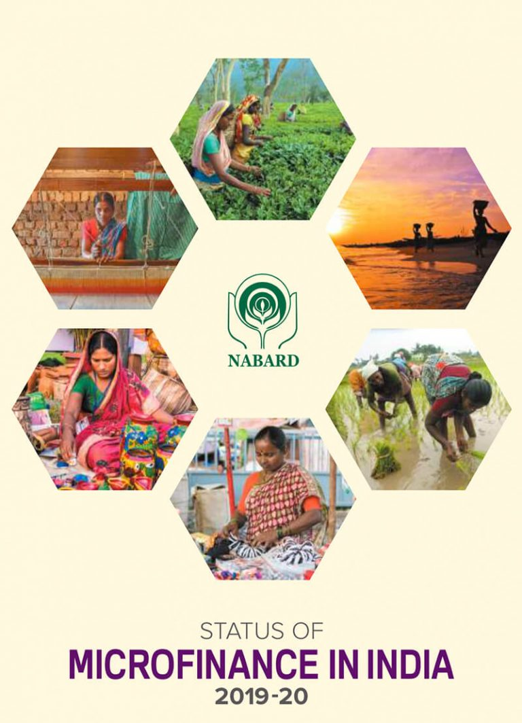NABARD's initiatives have significantly impacted rural India's financial landscape and development. It has facilitated credit flow to rural areas, supported infrastructure development, and empowered rural communities through various programs. NABARD continues to play a vital role in fostering inclusive and sustainable growth in rural India.

**2.3 International Scenario**

* **Evolution of Microfinance:**
  + The Grameen Bank model and its impact on poverty reduction.
  + The Microfinance Summit and the focus on reaching the "unbanked billions."
  + Debates on the social and economic impact of microfinance.
* **Global Trends:**
  + Integration of fintech and mobile banking in microfinance delivery.
  + Focus on social performance management and responsible lending practices.
  + Emergence of impact investing to support sustainable microfinance models.
* **India's Position in Global Microfinance:**
  + India as a leading player in microfinance with a large MFI network.
  + Learning from international experiences for regulatory frameworks and best practices.
  + Contributing to the global dialogue on responsible and sustainable microfinance.

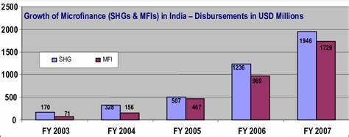

**Chapter 3: Presentation of Data Analysis and Findings**

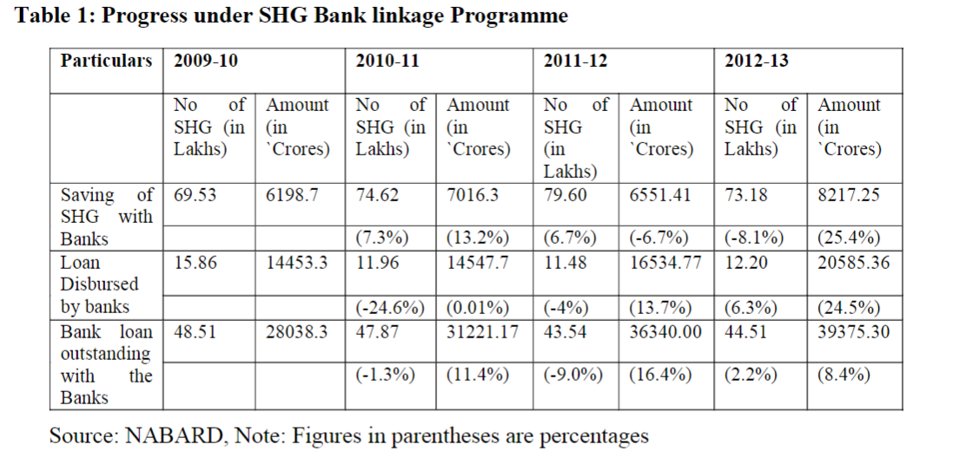

**Interpretation**

**(a) Savings of SHGs with the Banks:** Table 1 depicts the saving of SHGs with banks, as we see, in the year 2009-10, 69.53 lakh SHGs were having a saving account with the banking sector with saving of 6198.7 crore. Further, in 2011-12 a total of 79.60 lakh SHGs were having saving account with saving 6551.41 as against 74.62 lakh SHGs with saving of ` 7016.3 crores in previous year. It shows that there has been a decline in amount of saving balances with the bank to the extent (-6.7%) as compared to previous year. A similar decline of number of SHGs savings linked to banks has also been observed in 2012-13 only 73.18 lakh SHGs linked to banks as against 79.60 lakh a year back. For the first time since the SHG-Bank linkage program was launched, there is a decline in the number of SHGs to the extent of (-8.1%) during the year 2012-13, though the savings harnessed by SHGs grew by 25.4%. Increasing awareness at the SHG level about the advantage of using the savings for internal loaning is also partly responsible for the decline in saving balance with banks.

**(b) Loan disbursed by banks:** During 2009-10, banks have financed 15.86 lakh SHGs, with bank loans of 14,453.30 crore, but as we see in the year 2010-11 bank extended fresh loan of 14547.7 crore to 11.96 SHGs. It has been showed a declining of nearly 25% in the number of SHG as compared to previous year. Further during the year 2012-13 the number of SHGs availing fresh loans by banks showed an increase of 6.3% and the quantum of fresh loans issued increased by 24.5% as compared to the previous year.

**(c) Loan Outstanding with the banks:** In the year 2009-10, total number of 48.51 lakh SHGs were having outstanding bank loans of 28,038.28 crore. Further, the number of SHGs having loans outstanding against them from banks declined by 9% during the year 2011-12 although the quantum of loans outstanding increased to `36340 crore (16.4% increase over last year). The growth in the loan outstanding of SHGs with banks in the year 2012-13 (8.4%) is almost 4 times the growth in the number of SHGs having outstanding loans with banks (2.2%). So, loan outstanding is responsible for increase in NPAs of SHG loans with banks.

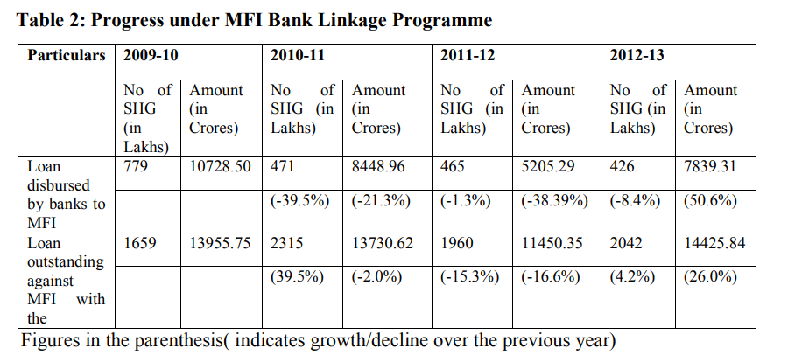

**Note:** Actual number of mFIs availing loans from Banks would be less than the figures shown as most of mFIs avail loans from more than one Bank/more than one loan account. Interpretation

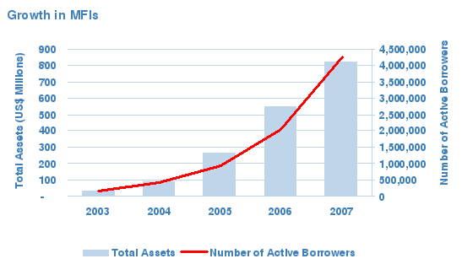

**Table 2** highlights that after 3 years of the mFIcrisis, the MFIs seem to be on the path of regaining the confidence of the clients as well as with the lending institutions. Fresh loans issued to MFIs by Banks showed a 50% increase in the year 2012-13 year as compared to previous year, while the number of MFIs having access to fresh loans declined by 8.4% indicating selective lending by the Banks. But loan outstanding in banks in the year 2012-13 was the highest compared to previous years.

**Interpretation**

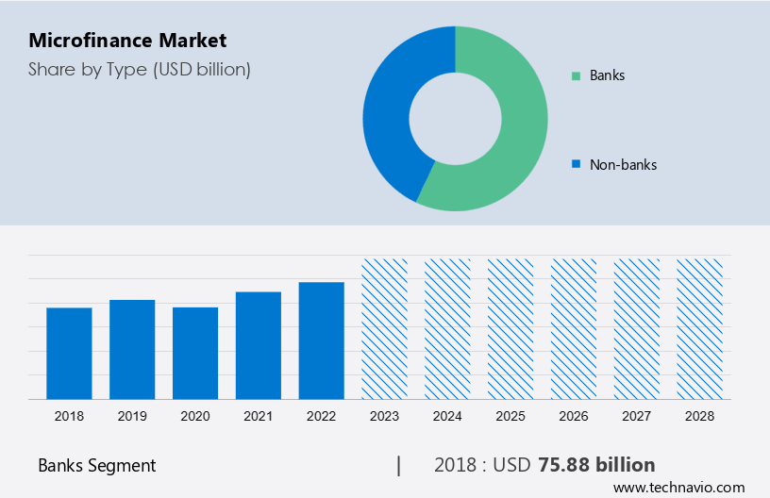**Table 3** shows that banks have financed 471 MFIs with bank loans of `8448.96 crore as against 779 MFIs with bank loans of` 10728.50 crore during 2010-11. Representing decline in bank loans disbursed. Further, during the same year (2010-11), the outstanding bank loans against 2315 MFIs was `13730.62 crore. While in 2009-10, SIDBI had financed 88 MFIs with financial assistance of ` 2665.75 crore and the loan outstanding against 146 MFIs was `3808.20 crore in the year 2009-10. As such the total exposure of banks and financial institutions to MFIs as on 2012-13 was to the tune of `14425.84 crore which shows increase in loan outstanding against MFI. As we see after 2009-10 Commercial Banks (and financial institutions like SIDBI) are losing their confidence in lending to mFIs is evident from the fact that the fresh lending to mFIs by banks during the year declined. There has also been a marginal decline in the number of mFIs availing fresh loans from Banks. If the trend continues, this sector is likely to face serious resource crunch and could affect its outreach plans soon. Overall, as we see among the agencies lending funds to mFIs, the major share belonged to Commercial Banks.

**Conclusion**

The microfinance sector has grown rapidly over the past few decades. The study concludes that for the first time in the year 2012-13 after the launch of SHGs BLP there is decline in the number of SHGs whose saving linked with banks. The study also finds out there was growth in the loan outstanding of SHG which was responsible for increases in NPAs. At last, we find out that the major share belongs to commercial banks when agency wise loan issued to MFI. Last steps should be taken to improve the performance of program launched under Micro finance time to time.

**Recommendations**

Based on the data analysis and findings on the impact of MFIs in India, here are some key recommendations:

**1. Expanding Outreach and Client Targeting:**

* Leverage technology (mobile banking) to reach geographically isolated populations.
* Partner with NGOs and community organizations to identify potential borrowers in underserved areas.
* Design microloan products tailored to the specific needs of different client segments (e.g., agriculture, small businesses).

**2. Promoting Client Protection and Responsible Lending:**

* Strengthen regulations to prevent over-indebtedness and ensure fair lending practices.
* Implement robust client protection mechanisms, including grievance redressal procedures.
* Promote financial literacy training to equip borrowers with the knowledge and skills to manage their finances effectively.

**3. Fostering Innovation and Sustainability:**

* Explore innovative models like cashless transactions and digital credit scoring for greater efficiency.
* Encourage partnerships between MFIs, banks, and fintech companies to leverage technology and financial resources.
* Develop sustainable funding strategies to ensure long-term viability of MFIs beyond donor dependence.

**4. Addressing Gender Equity and Social Impact:**

* Continue to prioritize women entrepreneurship through targeted programs and loan products.
* Integrate social performance management to monitor not just financial outcomes but also social impact on education, health, and empowerment.
* Partner with social welfare organizations to address broader community development needs alongside financial inclusion.

**5. Adapting to the Evolving Landscape:**

* Stay informed about global trends in microfinance, including the use of big data and impact investing.
* Invest in training and capacity building to equip MFI staff with the skills needed for adapting technologies and best practices.
* Remain responsive to regulatory changes and adapt business models to comply with evolving frameworks.

By implementing these recommendations, MFIs in India can continue to play a vital role in promoting financial inclusion, poverty alleviation, and overall economic development. They can ensure that their services empower individuals and communities while maintaining responsible and sustainable practices.

**Bibliography**

## ****Books:****

* Armendariz, B., & Morduch, J. (2005). The Economics of Microfinance. MIT Press.
* Christen, R. P., Rhyne, A. R., & Burgess, R. (2011). Microfinance Banking. Oxford University Press.
* Ghatak, M., & Levine, D. (2015). Financial Inclusion. Princeton University Press.
* Robinson, M. S. (2001). The Microfinance Revolution. World Bank Publications.
* Sharma, M. (2012). Microfinance and Women's Empowerment: A Critical Analysis. Routledge.

**Journal Articles:**

* Desai, V. A., & Joshi, A. V. (2016). Impact of Microfinance on Poverty in India. Journal of Economic Development, 41(1), 1-24.
* Kandamarani, V., & Rajeev, A. (2013). Microfinance and Financial Inclusion in India: Issues and Challenges. International Journal of Social Economics, 40(1), 74-90.
* Krishnamurthy, S., & Rajan, A. (2010). The Effects of Microfinance on Education. The Quarterly Journal of Economics, 125(2), 607-640.
* Roodman, D. (2012). The Impact of Microfinance on Poverty: A Review of the Evidence. Journal of Economic Literature, 50(1), 1-50.
* Sinha, S. (2017). Financial Inclusion and Microfinance in India: A Review. International Journal of Recent Research in Commerce & Management, 5(12), 14-20.

**Reports:**

* Microfinance Institutions Network (MFIN). (2023). India Microfinance Report. <https://mfinindia.org/>
* Reserve Bank of India (RBI). (2022). Report of the Working Group on Microfinance. <https://www.rbi.org.in/scripts/PublicationReportDetails.aspx?UrlPage=&ID=608>
* World Bank. (2021). Global Findex Database. <https://www.worldbank.org/en/publication/globalfindex>

**Websites:**

* Microfinance Institutions Network (MFIN): <https://mfinindia.org/>
* Sa-dhan (The Association of Microfinance Institutions in India): <https://www.sa-dhan.net/>
* Reserve Bank of India (RBI): <https://www.rbi.org.in/>